* 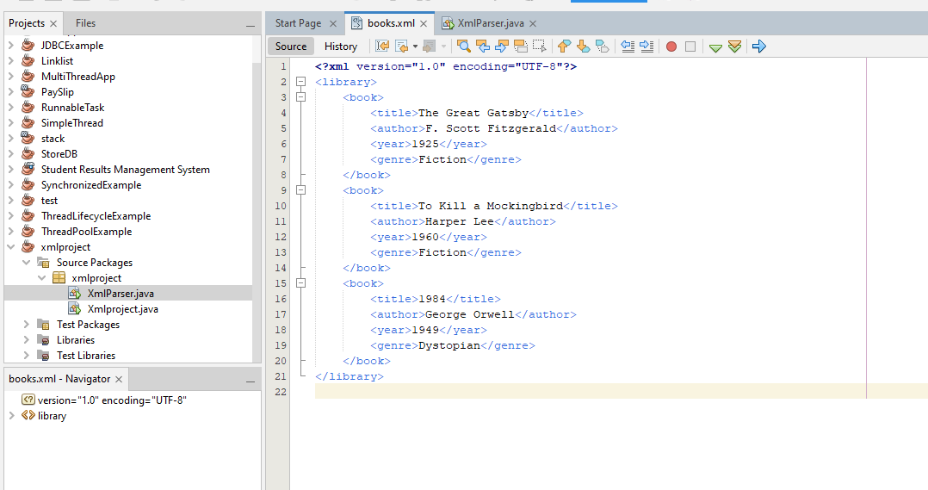**Creating First XML Document  
    
  - Create a new file named books.xml**
* **Parsing XML in Java**
* **Create a Java Class for XML Parsing:**

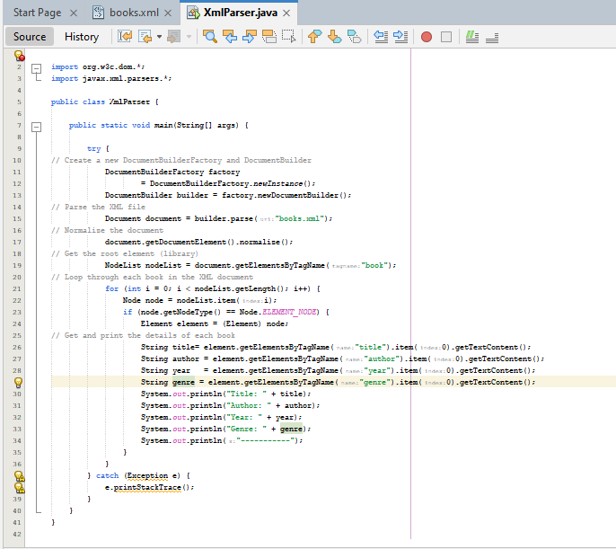

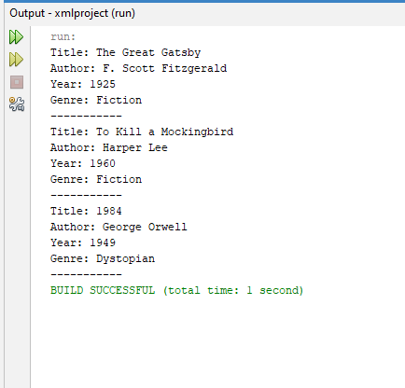

**Modifying XML Data**

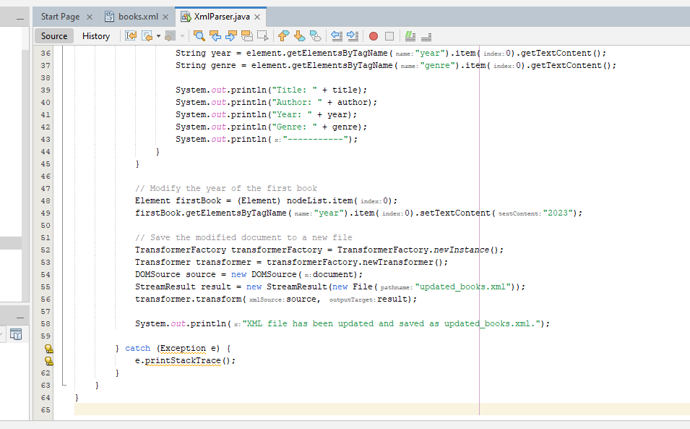

**Output  
  
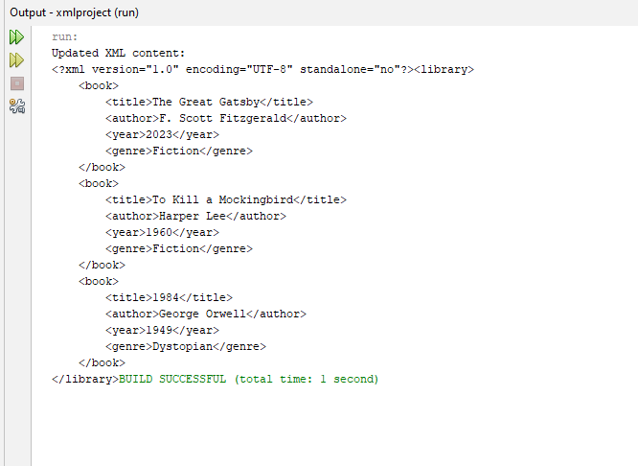**

**updated_books.xml  
  
